Renju lesson on May 24, 2001

Hello all! Welcome to Online Renju Class. We have studied d11 opening for a log time, but yet we are just in the half way somewhere. There is still a lot to learn.

We st the standard variant, same 13 moves. So far we have learned three 14th moves – j9 j8 k8. Today we will begin with 14-L8.
The following moves are very natural, and were shown in the games in WC 1997. There is no proof about 15-j9 being the best move, however, it was played in the first games of this variant, and since the outcome was satisfying for black, therefore people didn’t search for alternative 15th moves. At that time it was used by Japanese players. The 13th move and the following was unfamiliar for European players.
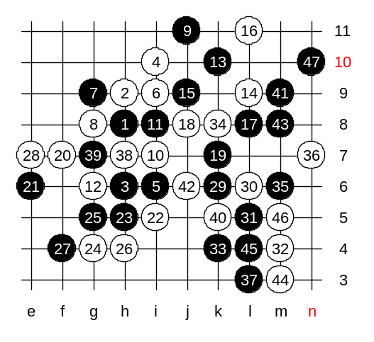
The conclusion of this variant – hard to say. So far black has been very successful in this variant. As an example of this variant, lets us show you the game I played with Nishizono in WC 99, and comment it. The following moves can be called as a theory of this variant. Those who attended the game students vs teacher last time, they know the first steps already. White uses a four to f7 to avoid being surrounded on the left side. Now, the best 23rd move is??? Yes, h5. It is different than the one student chose last time. As you see, the point k6 is very important for black. If black loses that point, then white can easily defend the right side. Black will play 23-h5 and fight for k6 point goes on. White’s 24-g4 is forced. Even though some players prefer 25-g7, I do not like that move. Black plays 25-g5 as stands on waiting position. Black has two powerful areas now, e7 area and k6 area. What can white do about it? H4 is somewhere in the middle, so it is the best block. It is quite active as well. Black plays f4 and continues waiting. What is black waiting for? Black has forced white into situation where white must make decision, to block left or right side. And black is now waiting the white’s final choice. Do you agree, if white blocks at k6 now, then black wins easily on the left side? Lets think logically. We agreed white must block the left side. And since white is going to defend on the left side, then as you learned from basic tactics before, we should choose the best defense among possible defense moves, that is most useful for ourselves. Mr Nishizono chose e7, and this move is the most useful for white self. Agree? Now, guess the next move. Yes, k6, finally!! The fight about the k6 spot is over – black got it first. Now, white position fell apart very fast. Lets see how it happened in the game.
Do you all get the idea of this 14th move now?
Black’s idea was to operate on both left and right sides at the same time and not let white to block both sides.

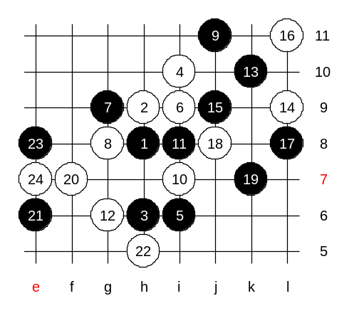
Now we will study about 22-h5. It is a new move. But yet white faces same problems – how to block left and right side at the same time. White plays e7 now. Can black have VCT on the left side now? Very hard question. Well, the black attack is very temptating, don’t you think? Therefore, guess what.. This is your advanced level homework, please find the black win.

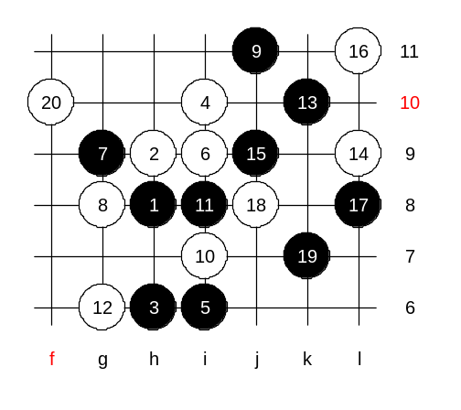

This is the medium level homework.
Please find the black win.

